# Flow Chart Design and Requirements

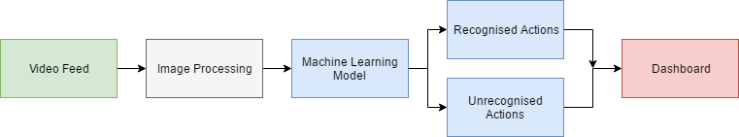

## Video Feed:

* Camera choice
* Video output format
* Video output quality

## Image Processing:

* Lowering frame rate and resolution to be suitable for the machine learning process
* Sampling to achieve a lower frame rate

## Machine Learning Model:

* Machine learning model, likely either 3D convolutional neural network.
* Recognized Actions
  + Classified actions which aid rehabilitation
* Unrecognized Actions
  + Actions which haven’t been identified

## Dashboard:

* User interface design
* Data representation
* Video scroll feature

## Video Feed

The video feed will be provided using a camera with a wide-angle view, this video stream will output, likely using an MP4/MPEG format. The cameras found, seen in the camera choice table, have a wide-angle view, are relatively cheap, have a large enough battery and memory life and are readily available for purchase. Of the recommended cameras, the “Kaiser Baas X90” fulfills all the requirements while being the most economical option. It has an angle of 1700 and is half the price of the only other camera with that angle. This camera is available for purchase locally from JB HI FI or from online retailers.

## Image Processing

The video feed will likely need to be imported into an environment like Matlab to perform sampling to lower the framerate, thus lowering the processing time of the machine learning component. The sampling will be dependent on how much data we can remove without it effecting the meaning of the video clip. Removing to much information and the machine learning (ML) process will not be processing the proper action sequences leading to errors. However, the sampling must reduce the amount of information to process to the point where the machine learning process can complete within a reasonable time frame.

In addition, to lowering video’s frame rate, the resolution also needs to be lowered. Alike the sampling it must be low enough that it doesn’t drastically effect the ML processing time and high enough so that it doesn’t lose any valuable information.

Overall the Image processing component is preparing the raw video feed to a point where the ML process takes a reasonable amount of time while containing all important actions.

## Machine Learning Model

Using a 3D deep learning model consecutive sequences will be categorized as actions and stored in classes. These classes will be documenting all the recognized actions performed throughout a normal day and sending these classes along with timelines to the dashboard. Any unrecognized actions will also be marked to highlight possible mismatches or unforeseen actions.

## Dashboard

The dashboard takes the output from the machine learning and displays the data in a clean GUI suited to a patient or physiologist. It presents to the user or healthcare professional a labeled graph with an actions axis and time axis, which allows the user to scroll through a loaded video to certain points where actions occur. These actions are described by a line graph which varies dependent on actions/hour.